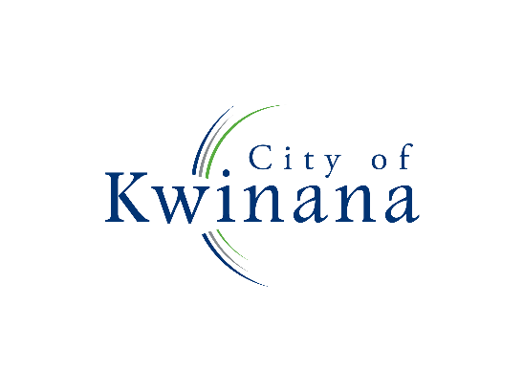

**PUBLIC NOTICE**

**CANCELLATION: ORDINARY COUNCIL MEETING**

In accordance with regulation 12(3) of the *Local Government (Administration) Regulations 1996*, notice is hereby given that the Ordinary Council Meeting scheduled to be held on Wednesday, 24 July 2024 has been cancelled as there is no business to be transacted.

The next Ordinary Council Meeting after this date is scheduled to be held on Wednesday, 14 August 2024.

Wayne Jack

**Chief Executive Officer**